HW 9

20184448 조민기

Prob 1

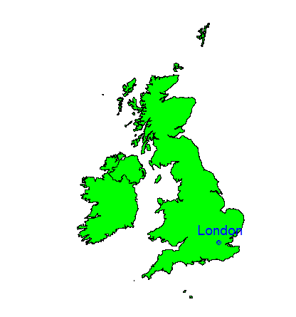

**Prob 2**  
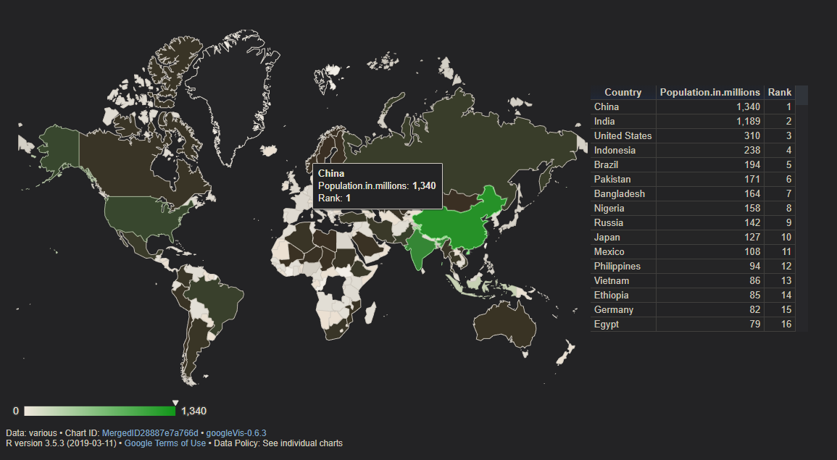

The 95% confidence interval is [4.358259, 4.399123]